L2-W2-DBS301-select-range-order

*STEP 1: rename the file to L2-your id name*

*STEP 2: Put the SQL and the results after each question below*

*STEP 3: Submit on Blackboard.*

Name: Abdul Rehman, Seneca ID: 149019176

1 Display the employee_id, last name and salary of employees earning in the range of $8000 to $15,000. Sort the output by top salaries first and then by last name.

Ans 1)

**Statement:**

select employee_id, last_name, salary

from employees

where salary BETWEEN 8000 AND 15000

order by salary desc, last_name;

**Output:**

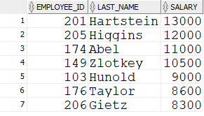

2 Modify previous query (#1) so that additional condition is to display only if they work as Programmers or Sales Representatives. Use same sorting as before.

Ans -2)

**Statement:**

select employee_id, last_name, salary, job_id

from employees

where (salary BETWEEN 8000 AND 15000)

AND (job_id IN('IT_PROG','SA_REP'))

order by salary desc, last_name;

**Output:**

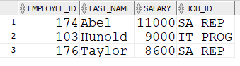

Rows:3

3 The Human Resources department wants to find high salary and low salary employees. Modify previous query (#2) so that it displays the same job titles but for people who earn outside the given salary range from question 1. Use same sorting as before.

Ans-3)

**Statement:**

select employee_id, last_name, salary, job_id

from employees

where (salary NOT BETWEEN 8000 AND 15000)

AND (job_id IN('IT_PROG','SA_RAP’))

order by salary desc, last_name;

**Output:**

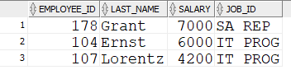

4 The company needs a list of long term employees, in order to give them a thankyou dinner. Display the last name, job_id and salary of employees hired before 1998. List the most recently hired employees first.

Ans-4)

**Statement:**

select last_name, job_id, salary, hire_date

from employees

where hire_date <'98-01-01'

order by hire_date desc;

**Output:**

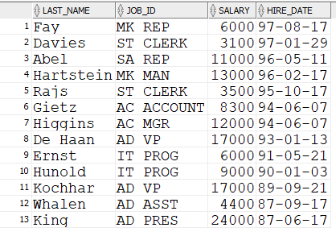

5 Modify previous query (#4) so that it displays only employees earning more than $10,000. List the output by job title alphabetically and then by highest paid employees.

Ans 5-)

**Statement:**

select last_name, job_id “Job Title”, salary, hire_date

from employees

where hire_date <'98-01-01'

AND salary > 10000

order by job_id, salary;

**Output:**

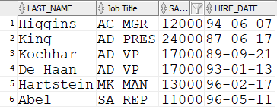

Rows:6

6 Display the job titles and full names of employees whose first name contains an ‘e’ or ‘E’ anywhere. The output should look like:

Job Title Full name

--------------------------------------

AD_VP Neena Kochhar

… more rows

Ans 6-)

**Statement:**

select job_id as "Job Title", trim(first_name) || ' ' || trim(last_name) as "Full Name"

from employees

where UPPER(first_name) LIKE '%E%';

**Output:**

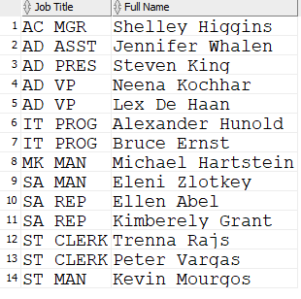

Total: 14 rows

7 Create a report to display last name, salary, and commission percentage for all employees that earn a commission.

Ans -7)

**Statement:**

select last_name, salary,commission_pct

from employees

where commission_pct is not null;

**Output:**

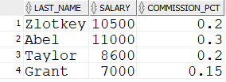

Rows: 4

8 Do the same as question 7, but put the report in order of descending salaries.

**Statement:**

select last_name, salary,commission_pct

from employees

where commission_pct is not null

order by salary desc;

**Output:**

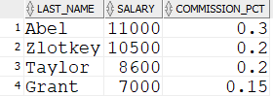

Rows: 4

9 Do the same as 8, but use a numeric value instead of a column name to do the sorting.

**Statement:**

select last_name, salary,commission_pct

from employees

where commission_pct is not null

order by 2 desc;

**Output:**

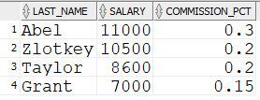

Rows:4